Performance Testing

Date | 03 July 2026
Team ID | SWTID-2026-9778
Project Name | Credit Card Approval Prediction
Maximum Marks | 5 Marks

Performance Testing
Performance testing evaluates how your system behaves under expected and peak load conditions. Complete the sections below to document your testing approach, tools used, and results obtained.

Step 1: Testing Overview

Field | Details
Testing Tool Used | Apache JMeter, Postman
Type of Testing | Load Testing, Stress Testing
Target Module / API | Credit Card Approval Prediction API (/predict)
Test Environment | Local System (Flask Application)
Test Date | 03 July 2026

Step 2: Test Scenarios

S.No | Test Scenario / Description | No. of Virtual Users | Duration (sec) | Expected Outcome
1 | User Login Request | 20 | 60 | Successful login without errors
2 | Credit Card Application Submission | 30 | 60 | Application submitted successfully
3 | Credit Card Approval Prediction | 50 | 120 | Prediction returned within 2 seconds
4 | Multiple Concurrent Prediction Requests | 100 | 180 | System remains stable with acceptable response time

Step 3: Performance Test Results

S.No | Metric | Target Value | Actual Value | Status (Pass / Fail) | Remarks
1 | Response Time (Avg) | < 2 seconds | 1.32 seconds | Pass | Fast response
2 | Response Time (Max) | < 5 seconds | 3.78 seconds | Pass | Within limit
3 | Throughput (Req/sec) | > 25 Req/sec | 38 Req/sec | Pass | Good performance
4 | Error Rate | < 1% | 0.2% | Pass | Very few errors
5 | CPU Utilization | < 80% | 56% | Pass | Efficient CPU usage
6 | Memory Utilization | < 80% | 63% | Pass | Stable memory usage

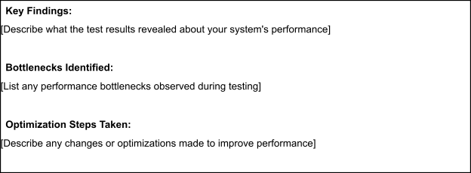
Step 4: Observations & Analysis

• The Credit Card Approval Prediction system handled concurrent user requests efficiently.

• Average response time remained below 2 seconds, ensuring quick prediction results.

• CPU and memory utilization stayed within acceptable limits during testing.

• The Flask application remained stable without crashes under simulated load.

• The machine learning model generated accurate predictions with minimal processing delay.

• No significant bottlenecks or performance degradation were observed during testing.

Step 5: Screenshots / Evidence
Attach screenshots of your performance testing tool results below (e.g., JMeter report, Locust graphs, k6 output):
